Product name | Confidentiality level
Product version | Total 8 pages

HUAWEI AR Engine Development Guide (Java)

Prepared by | Guo Zejin (employee ID: 00168222) | Date | 2018-04-24
Reviewed by |  | Date
Approved by |  | Date


Huawei Technologies CO., LTD.
All Rights Reserved

Revision Record
Date | Revision Version | CR ID/Defect ID | Section No. | Change Description | Author
2018-04-24 | 0.6 |  |  | Initial draft completed | Guo Zejin (employee ID: 00168222)

Contents
1 Environmental Development Preparations 5
1.1 Hardware Preparations 5
1.2 Software Preparations 5
1.3 Debugging Program Sample 5
2 Develop AR Apps Based on HUAWEI AR Engine 6
2.1 Modify Manifest 6
2.2 Import HUAWEI AR Engine SDK 7

List of Figures
Figure 1-1 HUAWEI AR Engine project sample 5
Figure 1-2 Device selection 6
Figure 1-3 Demo effects 6
Figure 2-1 Directory structure sample 7

Environmental Development Preparations

Hardware Preparations
Prepare a Huawei P20, P20 Pro (used in this article as an example), or Mate RS mobile phone, a PC, and a Type-C data cable.

Software Preparations
Install Android Studio version 3.0 or later and Android SDK Platform version 7.0 (API level 24) or later on your PC.
Download the HUAWEI AR Engine development kit from the official HUAWEI Developer website:
http://developer.huawei.com/consumer/cn/devservice/develop/mobile
Download the HUAWEI AR Engine Server apk from HUAWEI APP Market（search “HUAWEI AR Engine”）
Install HUAWEI AR Engine Service apk on your P20:
adb install –r "HUAWEI AR Engine Service_vx.x.x.apk"

Debugging Program Sample
Open HUAWEI AR Engine Demo in Android Studio, as shown in Figure 1.
              - HUAWEI AR Engine project sample
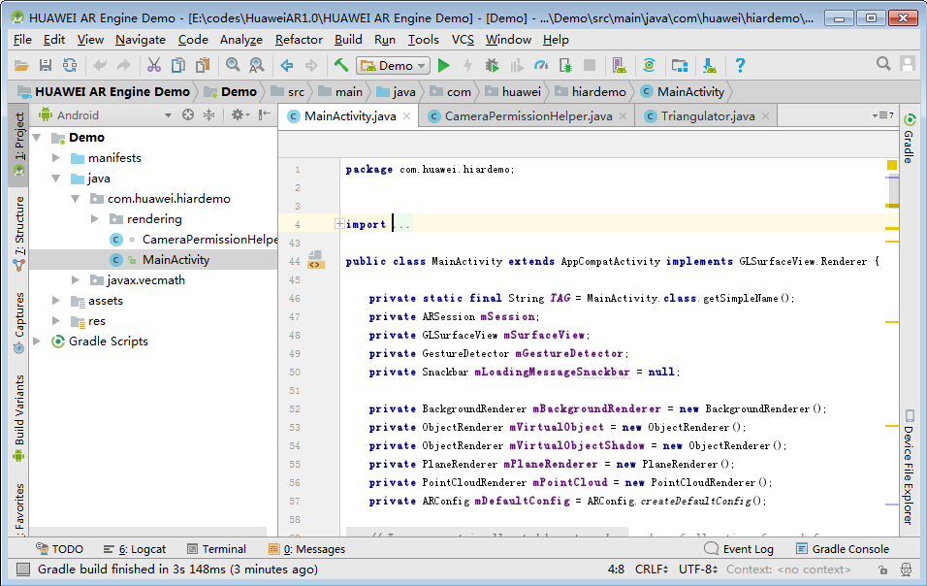

Connect your P20 Pro to your PC using the Type-C data cable, then click the Run button on Android Studio and select the device, as shown in Figure 2.
              - Device selection
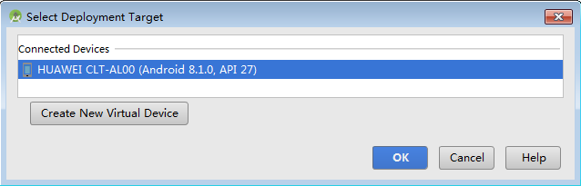

The HUAWEI AR Engine Demo will run on the P20 Pro. After authorizing the Camera permission, align the rich textured plane and slowly move the phone as Demo recognizes the plane, then touch the phone screen to place the virtual object, as shown in Figure 3.
              - Demo effects
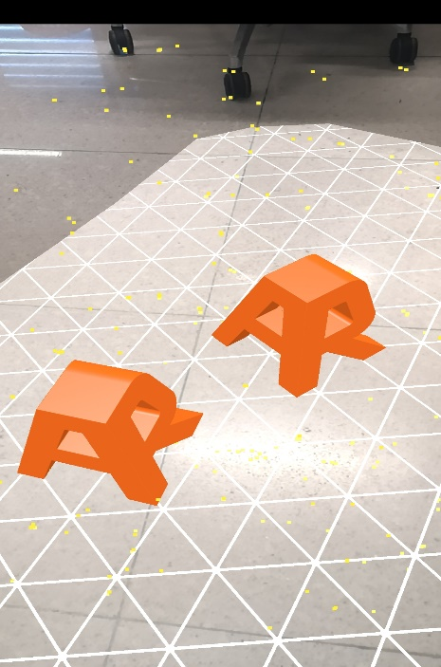

Develop AR Apps Based on HUAWEI AR Engine

Modify Manifest
Modify the app's Manifest file to indicate the app's dependency on HUAWEI AR Engine. There are two types of app dependencies on HUAWEI AR Engine: optional and required.
Optional dependency indicates that when your device supports HUAWEI AR Engine, the app has one or more features associated with HUAWEI AR Engine. The app can also run on devices that do not support HUAWEI AR Engine.
For optional dependency, the Manifest file can be written as follows:
<uses-sdk android:minSdkVersion="{14 or higher}" />
...
<application>
...
<meta-data android:name="com.huawei.ar.engine" android:value="optional" />
...
Required dependency indicates that the app fully relies on the HUAWEI AR Engine. The app cannot be used when the device does not support HUAWEI AR Engine or when the device does not have HUAWEI AR Engine installed.
Based on the conditions, HUAWEI AppGallery will determine whether the type of Huawei device is applicable to the app or whether you need to download and install the HUAWEI AR Engine APK after downloading the app.
For required dependency, the Manifest file can be written as follows:
<uses-sdk android:minSdkVersion="{14 or higher}" />
...
<application>
...
<meta-data android:name="com.huawei.ar.engine" android:value="required" />
...

Import HUAWEI AR Engine SDK
Add the reference library HUAWEI AR Engine SDK_vx.x.x.aar to the project directory of the AR app, as shown in Figure 4.
              - Directory structure sample
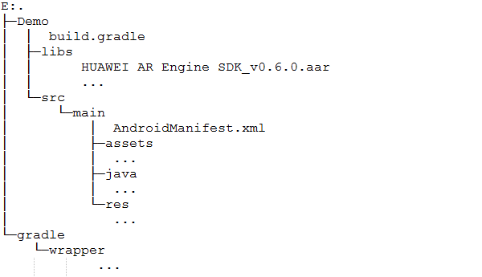
Add the following compilation dependencies to the build.gradle of the AR app project, and compile the HUAWEI AR Engine SDK into the AR app.
…
dependencies {
compile fileTree(include: ['*.aar'], dir: 'libs')
…
}

